|  |  |
| --- | --- |
| Activity | Data Type |
| Number of beatings from Wife | Discrete Data Type |
| Results of rolling a dice | Discrete Data Type |
| Weight of a person | Continuous Data Type |
| Weight of Gold | Continuous Data Type |
| Distance between two places | Continuous Data Type |
| Length of a leaf | Continuous Data Type |
| Dog's weight | Continuous Data Type |
| Blue Color | Discrete Data Type |
| Number of kids | Discrete Data Type |
| Number of tickets in Indian railways | Discrete Data Type |
| Number of times married | Discrete Data Type |
| Gender (Male or Female) | Discrete Data Type |

Q1) Identify the Data type for the Following:

Q2) Identify the Data types, which were among the following

Nominal, Ordinal, Interval, Ratio.

|  |  |
| --- | --- |
| Data | Data Type |
| Gender | Nominal Data Type |
| High School Class Ranking | Ordinal Data Type |
| Celsius Temperature | Interval Data Type |
| Weight | Ratio Data Type |
| Hair Color | Nominal Data Type |
| Socioeconomic Status | Ordinal Data Type |
| Fahrenheit Temperature | Interval Data Type |
| Height | Ratio Data Type |
| Type of living accommodation | Nominal Data Type |
| Level of Agreement | Ordinal Data Type |
| IQ(Intelligence Scale) | Interval Data Type |
| Sales Figures | Ratio Data Type |
| Blood Group | Nominal Data Type |
| Time Of Day | Interval Data Type |
| Time on a Clock with Hands | Interval Data Type |
| Number of Children | Ordinal Data Type |
| Religious Preference | Nominal Data Type |
| Barometer Pressure | Interval Data Type |
| SAT Scores | Interval Data Type |
| Years of Education | Ratio Data Type |

Q3) Three Coins are tossed, find the probability that two heads and one tail are obtained?

**ANS:** 3/8

Explanation :-

(HHH,HHT,HTH,THH,TTH,THT,HTT,TTT)

Q4) Two Dice are rolled, find the probability that sum is

1. Equal to 1
2. Less than or equal to 4
3. Sum is divisible by 2 and 3

**ANS:**

**a**)0 **b**)1/6 **c**) 1/6

Explanation:-

**a)**The probability of getting sum = 1 is 0 . p(1)=0

**b-)** When Two dies are thrown ,the probability less than or equal to 4 is (1,1),(1,2),(1,3),(2,1),(3,1) ,Therfore

* Number of Outcomes=6
* Total number of possibilities=36

Probability= Number of Outcomes / Total number of possibilities

=6/36

=1/6

Therefore,The probability of getting Less Than Or Equal To 4 is 1/6

**c-)** The probability of getting the sum which is divisible by 2 and 3 is 6/36=1/6

outcomes =(1,5),(2,4),(3,3),(4,2),(5,1),(6,6)

Q5) A bag contains 2 red, 3 green and 2 blue balls. Two balls are drawn at random. What is the probability that none of the balls drawn is blue?

**ANS:**

**Total number of balls = (2 + 3 + 2) = 7**

**Let ‘S’ be the sample space**

**To find number of different combinations 🡪 nCr = n! / r!(n−r)!**

**Then, n(S) = Number of ways of drawing 2 balls out of 7 = 7C2​**

**n(S) = 7! / 2!(7-1)! = (7×6) / (2×1) = 21**

**Let E = Event of drawing 2 balls in which none of them is blue.**

**Therefore, n(E) = Number of ways of drawing 2 balls out of (2 + 3) balls.**

**N(E) = 5C2 = (5×4) / (2×1) = 10**

**P(E) = n(E) / n(S)​= 10 / 21 = 0.47**

Q6) Calculate the Expected number of candies for a randomly selected child

Below are the probabilities of count of candies for children (ignoring the nature of the child-Generalized view)

|  |  |  |
| --- | --- | --- |
| CHILD | Candies count | Probability |
| A | 1 | 0.015 |
| B | 4 | 0.20 |
| C | 3 | 0.65 |
| D | 5 | 0.005 |
| E | 6 | 0.01 |
| F | 2 | 0.120 |

Child A – probability of having 1 candy = 0.015.

Child B – probability of having 4 candies = 0.20

**ANS:**

Expected number of candies for a randomly selected child :

=  1 * 0.015  + 4*0.20  + 3 *0.65  + 5*0.005  + 6 *0.01  + 2 * 0.12

= 0.015 + 0.8  + 1.95 + 0.025 + 0.06 + 0.24 =   3.090

Q7) Calculate Mean, Median, Mode, Variance, Standard Deviation, Range & comment about the values / draw inferences, for the given dataset

* For Points,Score,Weigh>

Find Mean, Median, Mode, Variance, Standard Deviation, and Range and also Comment about the values/ Draw some inferences.

**Use Q7.csv file**

**ANS:**

**1) Points :-**

Mean = 3.596563

Median = 3.695

Mode = 3.07

Variance = 0.285881

Standard Deviation = 0.534679

Range = 2.17

**2) Score :-**

Mean = 3.21725

Median = 3.325

Mode = 3.44

Variance = 0.957379

Standard Deviation = 0.978457

Range = 3.911

**3) Weigh :-**

Mean = 17.84875

Median = 17.71

Mode = 17.02

Variance = 3.193166

Standard Deviation = 1.786943

Range = 8.4

**Inferences:**

1)The given data of points, scores, weights are shifted towards left and its tail on the right side.

2)It is a positively/right-skewed distribution.

3) Points dataset is a bimodal because it is having two modes and score, weight are unimodal because it having single mode.

Q8) Calculate Expected Value for the problem below

1. The weights (X) of patients at a clinic (in pounds), are

108, 110, 123, 134, 135, 145, 167, 187, 199

Assume one of the patients is chosen at random. What is the Expected Value of the Weight of that patient?

**ANS:**

Expected Value = ∑ ( probability * Value ) = ∑ P(x) * E(x)

There are 9 patients

Probability of selecting each patient P(x) = 1/9

E(x) = {108, 110, 123, 134, 135, 145, 167, 187, 199}

Expected Value = { (1/9)(108) + (1/9)110 + (1/9)123 + (1/9)134 + (1/9)135 + (1/9)145 + (1/9(167) + (1/9)187 + (1/9)199 }

= (1/9) ( 108 + 110 + 123 + 134 + 135 + 145 + 167 + 187 + 199)

= (1/9) (1308) = 145.33

Expected Value of the Weight of that patient = 145.33

Q9)Calculate Skewness, Kurtosis & draw inferences on the following data

Cars speed and distance

Use Q9_a.csv

SP and Weight(WT)

Use Q9_b.csv

**ANS:**

**A) Index, Speed and Distance**

Skewness of Index is: 0.0

Skewness of Speed is: -0.11395477012828319

Skewness of Distance is: 0.7824835173114966

Kurtosis of Index is: -1.2009603841536614

Kurtosis of Speed is: -0.5771474239437371

Kurtosis of Distance is: 0.24801865717051808

**Inference**:

The given data of speed are shifted towards right and its tail on the left side, it is a negatively/left-skewed distribution.

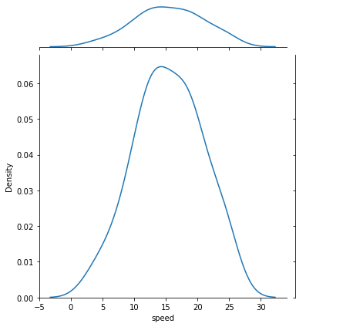

The given data of dist are shifted towards left and its tail on the right side, it is a positively/right-skewed distribution.

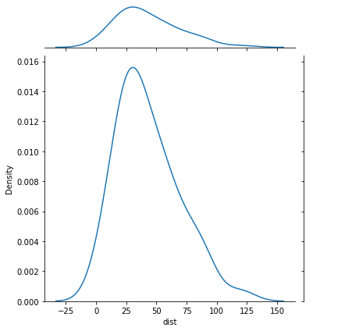

1. SP and Weight(WT)

Skewness of SP is: 1.5814536794423764

Skewness of Weight is: -0.6033099322115126

Kurtosis of SP is: 2.7235214865269244

Kurtosis of Weight is: 0.8194658792266849

**Inference:**

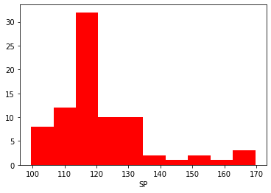

Most data points of SP are shifted towards left and its tail on the right side, it is a positively/right-skewed distribution.

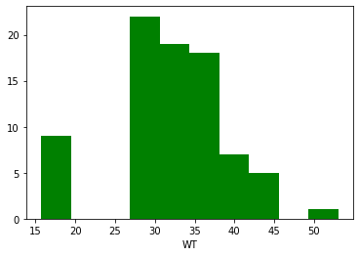

Most data points of WT are shifted towards right and its tail on the left side, it is a negatively/left-skewed distribution.

Q10) Draw inferences about the following boxplot & histogram



**Histogram:**

* Chick weight data is right skewed /positively skewed
* More than 50% Chick Weight is between 50 to 150
* Most of the chick weight is between 50 to 100



**Boxplot:**

* The data is right skewed/positively skewed
* There are outliers at upper side

**Q11)** Suppose we want to estimate the average weight of an adult male in Mexico. We draw a random sample of 2,000 men from a population of 3,000,000 men and weigh them. We find that the average person in our sample weighs 200 pounds, and the standard deviation of the sample is 30 pounds. Calculate 94%,98%,96% confidence interval?

**ANS:**

**Confidence Interval for 94% is: (198.738325292158, 201.261674707842)**

**Confidence Interval for 98% is: (198.439438404299, 201.560561595700)**

**Confidence Interval for 96% is: (198.622303348133, 201.377696651866)**

**Q12)** Below are the scores obtained by a student in tests

**34,36,36,38,38,39,39,40,40,41,41,41,41,42,42,45,49,56**

1. Find mean, median, variance, standard deviation.
2. What can we say about the student marks?

**ANS:**

1. **Mean :** 34+36+36+38+38+39+39+40+40+41+41+41+41+42+42+45+49+56 / 18

= 738 / 18 = **41.0**

**Median :**

(40+41)/2

= 81/2 **= 40.5**

**Variance :**

(49+25+25+9+9+4+4+1+1+0+0+0+0+1+1+16+64+225)/18

= 434/18 **= 24.111**

**Standard Deviation : 4.9103**

**ii)**

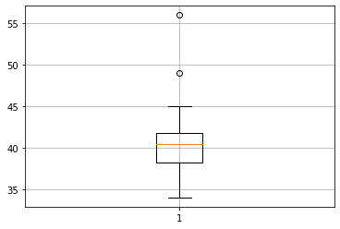

From above plot we can say that mean of marks of student is 41 which is slightly greater than median. Most of the students got marks in between 40-42, there are two outlier 49,56.

Q13) What is the nature of skewness when mean, median of data are equal?

**ANS:**

When mean, median of data are equal there is no skewness.The distribution is both symmetric and unimode.

Q14) What is the nature of skewness when mean > median ?

**ANS:**

**If the mean is greater than the median, the distribution is positively skewed.**

Q15) What is the nature of skewness when median > mean?

**ANS:**

**If the mean is less than the median, the distribution is negatively skewed.**

Q16) What does positive kurtosis value indicates for a data ?

**ANS:**

**Positive values of kurtosis indicates that distribution is peaked and possesses thick tails.**

Q17) What does negative kurtosis value indicates for a data?

**ANS:**

Negative values of kurtosis indicates that a distribution is flat and has thin tails.

Q18) Answer the below questions using the below boxplot visualization.



What can we say about the distribution of the data?

**ANS:**

The peak of the given boxplot or the most of data points are situated towards right side and the tail is at left side of boxplot.

What is nature of skewness of the data?

**ANS:**

Negative Skewness.

What will be the IQR of the data (approximately)?   
**ANS:**

IQR = upper quartile – lower quartile

= 18 – 10 = 8

Q19) Comment on the below Boxplot visualizations?



Draw an Inference from the distribution of data for Boxplot 1 with respect Boxplot 2.

**ANS:**

* By observing both the boxplots there is no skewness but whisker level is high in boxplot 2 as compared to boxplot 1.
* The IQR of the first boxplot is between 255 to 280
* The IQR of the second boxplot is between 225 to 315
* And there is no outliers in both the boxplots

Q 20) Calculate probability from the given dataset for the below cases

Data _set: Cars.csv

Calculate the probability of MPG of Cars for the below cases.

MPG <- Cars$MPG

* 1. P(MPG>38)
  2. P(MPG<40)
  3. P (20<MPG<50)

**ANS:**

Probability for MPG>38 is: 0.3475939251582705

Probability for MPG<40 is: 0.7293498762151616

Probability for 20<MPG<50 is: -0.013116469610523339

**Explanation-**

a)P(MPG>38)=1-pnorm(38,34.422,9.13144)=0.348

b)P(MPG>40)=1-pnorm(40,34.422,9.13144)=0.7293527

c)P(MPG>50)=1-pnorm(50,34.422,9.13144)-

(1-pnorm(20,34.422,9.13144))= -0.01311818

Q 21) Check whether the data follows normal distribution

1. Check whether the MPG of Cars follows Normal Distribution

Dataset: Cars.csv

**ANS:**

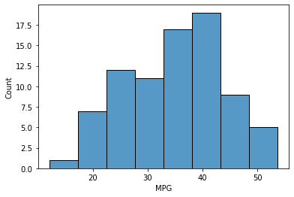

The data set is not a normal distribution, it is right skewed / positively skewed

1. Check Whether the Adipose Tissue (AT) and Waist Circumference(Waist) from wc-at data set follows Normal Distribution

Dataset: wc-at.csv

**ANS:**

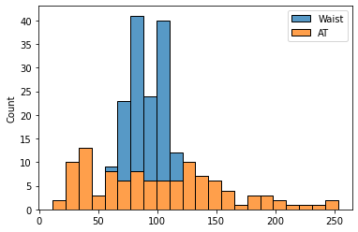

Both the Adipose Tissue (AT) and Waist Circumference(Waist) data set do not follow the normal distribution approximately (as mean and median of both the data are approximately different)

Q 22) Calculate the Z scores of 90% confidence interval,94% confidence interval, 60% confidence interval

**ANS:**

90% confidence interval Z-score: 1.64

94% confidence interval Z-score: 1.55

60% confidence interval Z-score: 0.25

Q 23) Calculate the t scores of 95% confidence interval, 96% confidence interval, 99% confidence interval for sample size of 25

**ANS:**

95% confidence interval t-score: 2.06

96% confidence interval t-score: 2.17

99% confidence interval t-score: 2.8

Q 24**)** A Government company claims that an average light bulb lasts 270 days. A researcher randomly selects 18 bulbs for testing. The sampled bulbs last an average of 260 days, with a standard deviation of 90 days. If the CEO's claim were true, what is the probability that 18 randomly selected bulbs would have an average life of no more than 260 days

Hint:

rcode 🡪 pt(tscore,df)

df 🡪 degrees of freedom

**ANS:**

T_Score is: -0.4714045207910317

P_value is: 0.32167411684460556